**Session report 07/02/2023:**

*LABAUVIE – RAFFAELLI EVA*

*ROB3*

For this session, I asked Xavier to print the wheel base on the Volumic 3D printer since it is big enough to print the wheel vertically, and be able to use less plastic as support.

To reduce the stands, I had to create chamfer so the structure is stronger.

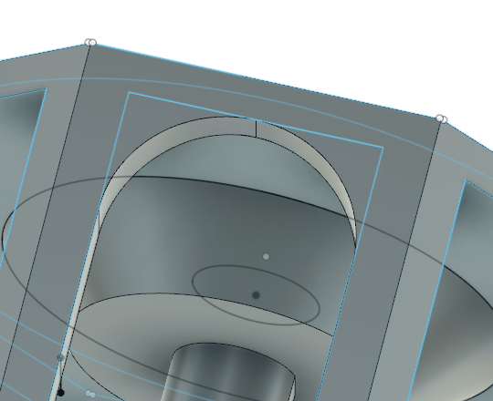

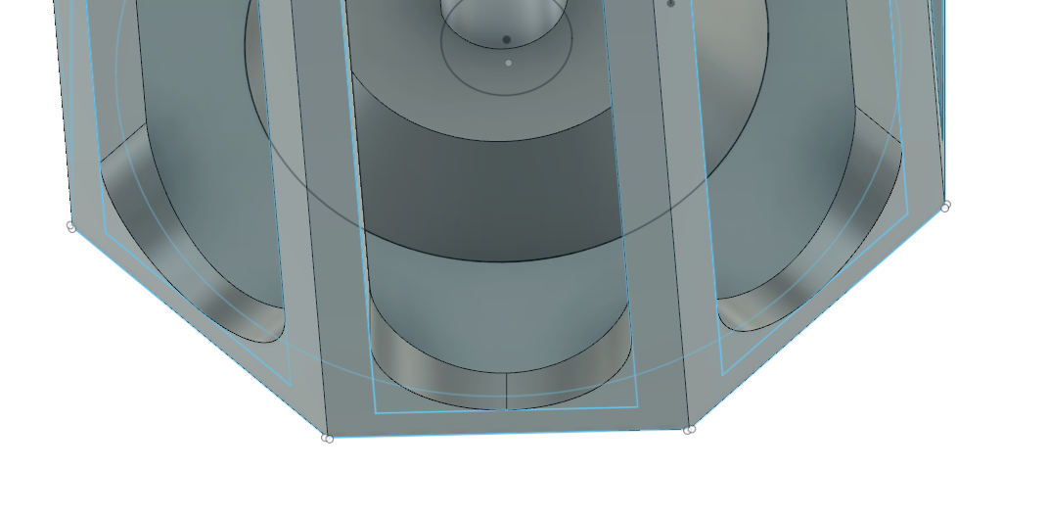

The printing will last around 11h so I will have to get it back the next day.

Here the result of the printing :

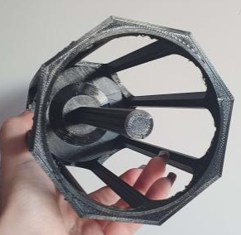

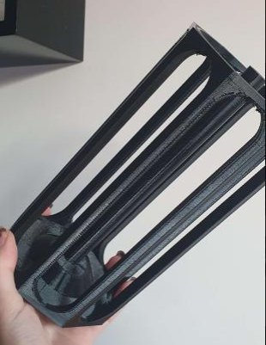

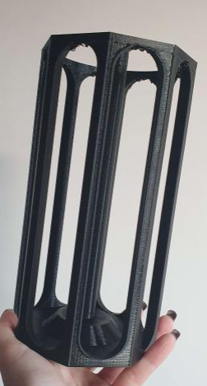

Next, I decided to try creating a virtual environment with Python, to create and train an artificil intelligence that will be used next in the Auvidea card.

I started by adding Python :

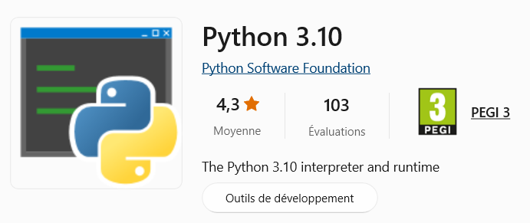

I had to create a directory on my Desktop :



Then I created a virtual environment



And actived it :



Now I have on my desktop :

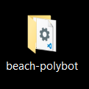

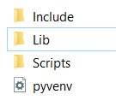

Then I installed TensorFlow

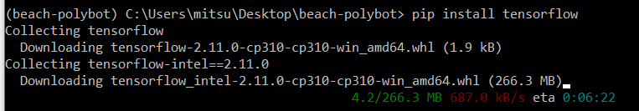

Now I need to search for images to train an IA next, so I’m downloading and making a good bank of images for trash and non trash.

